*California State University, Chico*

*Spring 2017*

ECON 483: Forecasting

Time Series Report

**Effects of Electronic Cigarettes on Youth Cigarette Consumption**

Jared Halterman

**Introduction:**

Cigarette consumption among high school students has always been a concern among health officials and parents. The increased risk of cancer, illness, asthma, and other correlated symptoms of cigarette consumption (higher amount of fights and sex without protection, etc), are a burden on taxpayers and people that have to exist around them (1). The reason why so many people are concerned about high school students puffing, is due to the addictive substance nicotine found in tobacco, which leads to a high chance of continued use of tobacco when they become adults, which exacerbates some of those issues I labeled earlier, such as the health concerns (2).

Although youth cigarette consumption has declined enormously since the late 1990’s, that does not mean that we should simply let youth smoking run its course (2). As we have seen from past data, there was actually an increase in high school cigarette consumption from 2001 to 2003, so we can never be too sure if this dangerous variable will shift backwards again in the future. In order to combat youth cigarette consumption, we need to look at all the variables which lead to the decline and/or increase of tobacco use among minors (2). If we discover that nicotine is too addictive or the portrayal of cigarettes in media is too cool for the young to resist temptation, then we should also look at substitutes.

Electronic cigarettes, (e-cigarettes, vaporizers, vapes), have recently seen an explosion of popularity among youth. Looking at Figure 1, we can see just how high the use of vaporizers have quickly risen in the last few years. The sharp upward slope of vaporizers around 2013-2014 seems to make the slope of cigarettes even steeper than normal. The influence of the electronic cigarette in high schools on cigarette consumption among high school students, is the effect I want to investigate. Whether it is a good alternative for students, or whether it might be a gateway drug is irrelevant in my study, but I will discuss it, for it would have some policy implications.

**Data Gathering:**

In order to conduct my analysis, I needed some stable and accurate data. The best source possible for this subject is from the Center of Disease Control, which is the leading national public health institute of the United States. On their website, there is numerous amounts of data which relates to my project.

Compiled from a list of surveys created, initially biennially, but now annually, for high school students to fill out, in regards to their drug/sex use, the data I gathered is the percentage of students who answered yes to using cigarettes and e-cigarettes in the last month. I copied the data from 1991 to 2015, because the last few years is when electronic cigarettes really become popular. To export this data into R, I had to hand copy the percentages of each year into Excel, save it as a .csv file, then simply download it and load it into R, after changing the directory to where the .csv file was stored.

Because there was no data on electronic cigarette usage among high school students before 2011, I made the assumption that there was no, or barely any, use of electronic cigarettes before that year. For the data points from 1991-2011 for the vape variable, I put a “0” for each of those years. On the effect on cigarettes, I believe the variable vape will have a negative correlation with cigarettes and the coefficient will be negative.

For the variable tax, I decided to go with the average state tax from 1997-2015. I had to export data on each State’s and U.S. Territory’s tax rate per year, from the CDC database. After I had the file opened up in Google Sheets, I had to use formulas to add up each State’s yearly reported tax for each year and divide by 50. I made sure to delete any extra U.S. Territories, as the surveys on high school cigarette use only included the states in the Union. The last adjustment I made to the data was to account each value for inflation, specifically 2017 dollars. The tax variable will have a negative relationship with cig and have a negative coefficient.

As there was no poverty data going all the way to 2015 on FRED, as I could find, I had to reverse image search some graphs I found on Google that were related. I found one that had the poverty trend from 1990-2015 and I thought it would be perfect. Unfortunately, the website will not allow you to download the data into .csv format, so I had to mouse over each point in order to get the correct value. In theory, the higher the poverty levels are, the higher cigarette consumption will be, so I am assuming that the coefficient for poverty will be positive.

**Specification and Two Model Analysis:**

Starting off the model, I threw vape, poverty, tax, L(tax), and L(cig) together as the regressors against cig. I added the lags because I thought that possibly, the effects of higher price in cigarettes would have an effect a year later, after teenage consumers of cigarettes noticed how much money they were losing, and I also thought the previous years’ cigarette consumption would be a reasonable explanation for current year cigarette consumption, as how inflation is explained. So the current model is cig~vape+poverty+tax+L(tax)

After running the model, (Figure 2), I saw that L(cig) and poverty really didn’t have much significance with their low t-scores and high p-values. L(tax) did have a p-value over .05, but I believed it was being manipulated by L(cig) and poverty. In order to fix this, I simply removed those two variables and made a new model. So the new specification is cig~vape+tax+L(tax). I compared the two with an anova test, which confirmed that the new specification has better fit. This still left me with a hard decision of which model to use for analysis, so I decided to test both models to see which one held the most OLS assumptions.

I checked each model’s normality, it seems that model1, has a higher distribution around zero for its residuals, than model 2, (Figure 5). I also ran a Breusch-Pagan test on both models in order to check to see if the homoskedastic assumption was true in either of the models, (Figure 6). As it turns out, model1 has a p-value high than .05 (barely), while model2 clearly suffers from heteroskedasticty. Running VIF tests to check for collinearity for each model (Figure 7) show that in model1, there is high collinearity is L(tax) and L(cig), but in model2, there is not.

With all the tests I ran checking for which model is the better fit, I decided to go with model2, even though it does have heteroskedasticity, it has less multicollinearity and has a better fit. These problems will need to be kept in mind while we survey the results this model gives us.

**Data Analysis and Policy:**

Looking at Figure 4, we can see the effect of each variable on high school cigarette consumption. All the p-values for each variable is very low and the T-values are generally high, this is a good sign that the model is fit. The high F-statistic shows that the model variables do play a role in high school cigarette consumption.

The current year tax has a very high negative correlation with the dependent. My output shows that for every $1 average increase in the state tax, cigarette consumption by high school students decreases by ~20%. Holding everything else constant, if we want to decrease youth smoking to nearly zero, through raising the tax, we should increase it by $.35. This is according to simple math, using my simple model. I do not believe it would work for the inelasticity of cigarettes would play a role here.

Electronic cigarettes do seem to play a role in smoking cessation, or maybe even preventing youth from starting. My model states that for every 1% increase in vape use among high school students, cigarette consumption among the same group, decreases by ~.5%. Using the same simple math as before, in order to decrease teenage cigarette consumption to ~0%, we should find a way to increase high school vape usage by an extra 28%. This might work as cigarettes and vaporizers are are almost a half for one substitute, according to my model.

**Conclusion:**

My data shows that in order to reduce high school cigarette consumption to near zero, we will either need to increase the tax even higher or increase the teen usage of e-cigarettes. However, my data may be misleading. First, there is some problems with model itself (heteroskedasticity). Second, by theory, the increase in vape use might not be students using it as a substitute for cigarettes. In fact, it might be students who have never smoked are now using vaporizers. If this is true, the whole purpose of my model will be bunk. Making teenagers nicotine dependent is not good either, for if it is found that vaporizers are just as bad as cigarettes, then now we have a whole generation of kids who are addicted to a damaging substance.

I *can* conclude that so far, there is no evidence that vaporizers are a gateway drug to cigarettes. If there was, we would see a positive relationship between the two, and if cigarette consumption is volatile, as it was in 2001-2003, then it shouldn’t be too difficult to have it jump up again, especially if vaporizers were a gateway.

**Figures and Tables**

Figure 1 

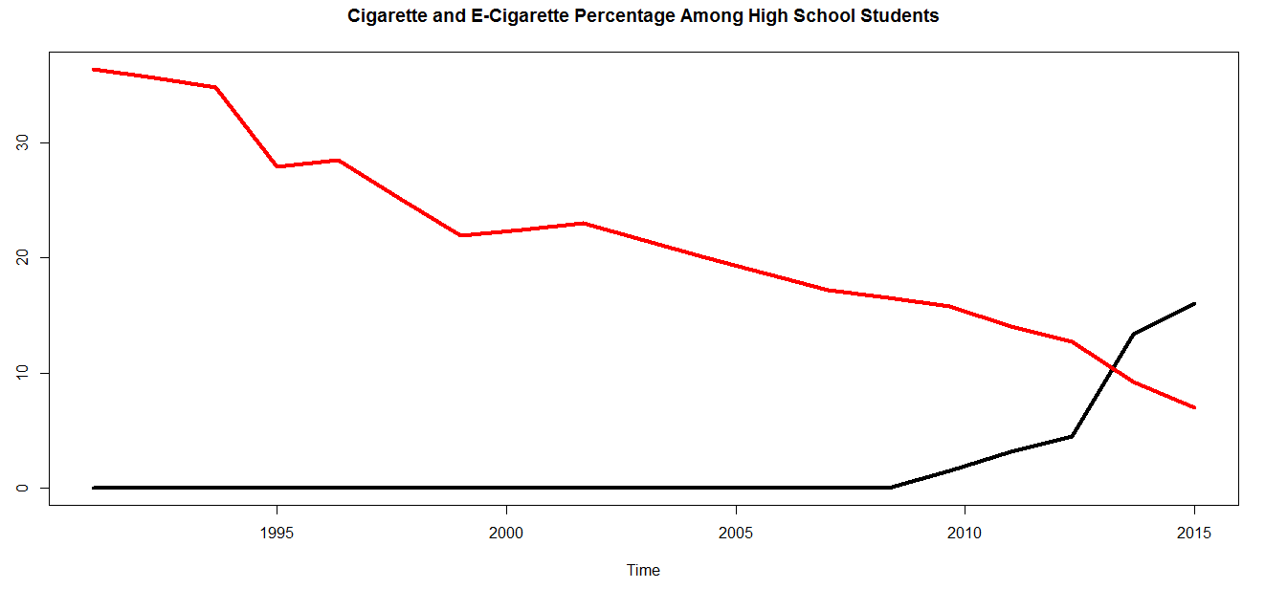

Figure 2

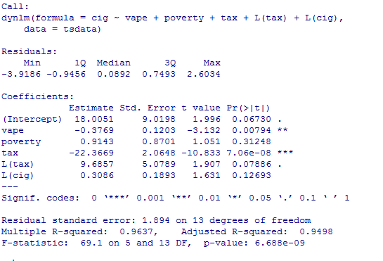

Figure 3

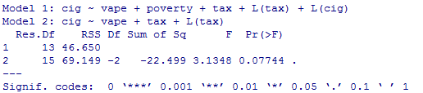

Figure 4

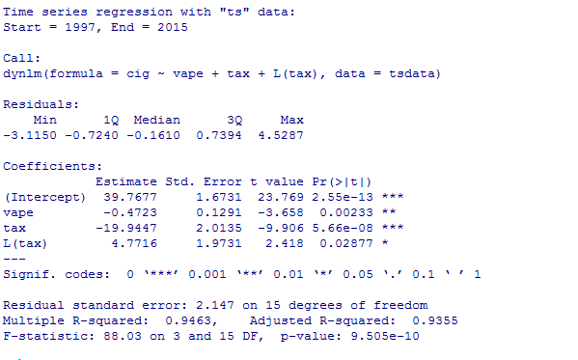

Figure 5

Model 1 Model 2

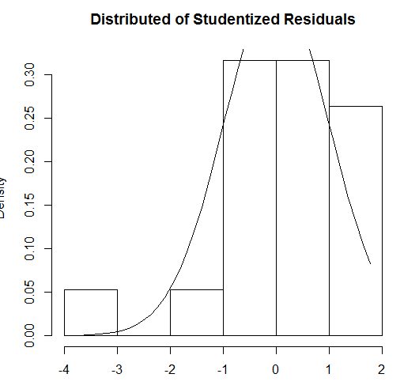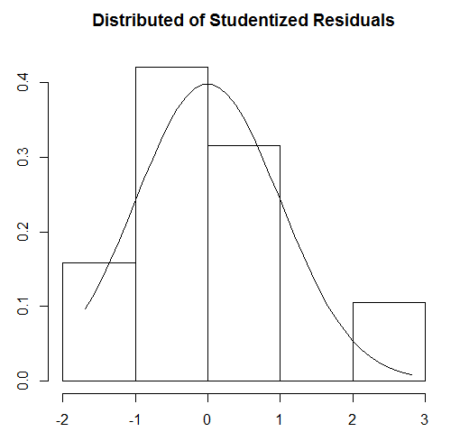

Figure 6



Figure 7

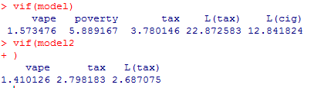

**Sources:**

1. Preventing tobacco use among youth and young adults : a report of the Surgeon General. – Atlanta, GA. : Dept. of Health and Human Services, Centers for Disease Control and Prevention, National Center for Chronic Disease Prevention and Health Promotion, Office on Smoking and Health; Washington, D.C. : For sale by the Supt. of Docs., U.S. G.P.O., 2012
2. "Youth and Tobacco Use." Centers for Disease Control and Prevention. Centers for Disease Control and Prevention, 14 Apr. 2016. Web.